Why the Evidence Mueller has for the Indicting 13 Russian Nationals is Fraudulent
It's almost a shame that a headline like that won't spark anything more than casual curiosity when you consider the charges Richard Mueller is looking into. The Russian company Concord Management decided to answer his charges in early May, which threw a wrench into Mueller's strategy.
I'm more interested in showing what Richard Mueller's sources are not, than who they are. This opens a much greater conspiracy that's playing out in a complicit US media today. What do I mean? The flawed source for both investigators and journalists that know anything about the Russian troll factory in St. Petersburg, Russia is Shaltai Boltai. They are supposed to be connected to the GRU (Russian Military Intelligence).
Fancy Bear is also supposedly the GRU hacking team that everyone is actually looking for. Shaltai Boltai is supposed to have those connections. But are these hackers an official Intel operation or was a criminal undertaking to discredit Russia?
Over a year ago, I found evidence of the identity of Crowdstrike's Fancy Bear, just short of a confession. When I looked into Shaltai Boltai, I found additional information that is even better for identifying Fancy Bear. The next article will detail that clearly.
Once it's clear that the source of Mueller's evidence, Russian hackers called Shaltai Boltai(Humpty Dumpty) , did NOT hack Concord Catering or the Russian government, we can cross off a couple of hackers from our list on our way to Fancy Bear. Shaltai Boltai tried unsuccessfully to confess to the DNC hacks.
They aren't the hackers they make themselves out to be. They are Information Operation (IO) specialists that were paid to build a narrative which became a convenient hook for Mueller to hang his coat on.
Unfortunately, the slam dunk he would have won if they stayed away was taken from his grasp the second real people materialized. You see, Robert Mueller has to prove the Internet Research Company existed in reality and did the things he alleges.
He now has to authenticate the communications from the Troll Farm that his Russian interference investigation is based on and he can't do it. This was the reason Mueller asked to delay the trial instead of moving forward. His case is built on fraudulent (nonexistent) evidence. Even that is laughable because what he is alleging goes against the grain of some of his foundational documentary evidence.
The source for Mueller's indictment are Russian traitors that were hired for the purpose of destroying Russia. Mueller's evidence was an Information Operation to discredit the Kremlin and that changes everything because fabricated evidence is still considered too tainted to use in a court of law, even if the defendant is Russian.
Let's get down to brass tacks and avoid any confusion. Once you understand that the original source of information for the Internet Research Agency, hackers calling themselves Shaltai Boltai (Humpty Dumpty) fabricated the evidence, you understand the irresolvable problem Mueller stepped into.
Mueller's problem in this scenario according to what should be a foundational article by Scott Humor at the Saker.is, the "Internet Research Agency" which existed only on paper, ceased to exist in 2015. It was liquidated and merged with construction retail company called TEKA. I found his article after almost finishing this one. He left little need for any additional research on the matter.
About the troll farm, he notes the results of a court case that an NGO was pushing to get legal recognition of the troll farm as a working business in St Petersburg. It didn't work out.
"One example, a woman with the last name Malcheva filed a lawsuit in court against the companies “Internet Research, LLC” and “TEKA, LLC,” claiming unpaid wages.
The court asked her to produce evidence of her work, and then denied her claim after she produced a photo of a computer with an IP address on its screen as evidence of her employment.
IP Address 109.167.231.85
inetnum: 109.167.231.0 – 109.167.231.255
netname: WESTCALL-NET
descr: S-Peterburg Hotel Corintia Wi-Fi
An IP address that was assigned to a luxury hotel in Saint-Petersburg. A hotel that was awarded multiple international awards for excellence. An immensely popular hotel among discriminating travelers. A very expensive hotel located in the center of a historic city. The woman claimed that she was an “online troll’ working from this location ten hours a day with hundreds of other virtual trolls. The judge didn’t believe her. Would you?"- Scott Humor Saker.is
Secondly, and more importantly is that although charged with treason by the Russian government, the "hackers" did not serve time for hacking. They served time for conspiring against the Russian government. This is an important point.
First things first, how do I know it is an information operation against the United States? Everything hinges on how carefully and accurately this single question is answered.
If Mueller is alleging that this entity interfered in the 2016 US election and all the information about it is faked, it is safe to say the word Information Operation.
The reason is simple. The "Anon" the information Mueller uses for his indictment about the Russian Internet Research Agency every MSM news story is based on, states quite clearly in the posts that it IS an Information Operation. Shaltai Boltai reiterates this fact throughout different posts!
If only this single fact is true, Robert Mueller needs to step down to answer some questions. The first one is why he would knowingly take part in a foreign influence operation to publicly destroy the credibility of the United States Government?
Before getting into some of the fraudulent information, watch how the source purposefully discredits itself. I don't think the hacker imagined things would bloom this large. The following are a couple of questions the hacker answered for a journalist. Question 2 was asked because this hacker group is anti-Putin and Russian government as it stands.
The answer to question 3 states they are an Information Operation seeking to influence (policy). While it is a surprise that even a highly politicized investigation would claim fabrications as legitimate evidence, it's more of a surprise that it wasn't caught by MSM . You'll see for yourself, the hackers were honest. Mueller, on the other hand is not.
From the b0ltai.wordpress.com June 5th, 2014 post- These were questions that a Russian journalist asked the Anon group that found the Russian Internet Research Agency(IRA) of St. Petersburg and released the information currently used by Mueller and the MSM including the New York Times.

"2. Journo-Many consider you a "wiring"(wire service) for the discharge of Kremlin secrets. What do you say to that?
Shaltai Boltai- How many people, so many opinions. We do not intend to prove or deny it. We will be told for already laid out "stories" and those that we will lay out.

3. Journo-What is your ultimate goal?
3. Shaltai Boltai- We never concealed it. The goal is published in our blog and twitter - we create realities and give meanings to words. More - trying to change reality, create another reality. To launch certain events according to a certain scenario. "

So, there it is. This informative post is a confession by the original source directly after posting information about the Russian Internet Research Agency for over one month in May 2014.
If the information that Mueller used in his indictment was true, it would still have to be thrown out of a court of law because of the source. In the US, a police officer can't lie to a judge or grand jury about probable cause to get a search or arrest warrant and expect anything he found to be admissible in court. Special Prosecutor Mueller can't either. He cannot cite information that :
- Was purported to be hacked and was obtained illegally if that were true
- Cannot use information where the source states the information was manufactured to create new realities, in this case political realities.
- Fake emails do not constitute evidence. None of the MSM stories even provide him with an inch of cover.
- He doesn't get a free pass today.
Let's step back and look at how this developed. The second point that deserves special attention from Robert Mueller's investigative team is the "Russians" shown through the hacked documents don't seem to speak Russian or English well. It's kind of like Mr. Bean does James Bond. It's funny and at the same time absurd because it could never work.
The Russian language mistakes are grammar school stuff like you'd expect from a foreigner. They consist of basic spelling, gender confusion, and other simple grammatical errors that won't be found in communications from law firms or multimillion dollar businesses.
This is important because according to Mueller the IRA(Internet Research Agency) is supposed to be composed of handpicked professional journalists, information war specialists, attorneys, and business people. These are supposed to be educated people. After all, they got past 19 Intel agencies right?
The hackers material almost conclusively shows that the Concord communications shown below were from people that use Russian as a 2nd language. I will post a link and show you how to search the blog easily. If they take the blog down, I saved it on the Wayback machine. It is entirely searchable and it is saved for posterity.
Next up, looking at the basic technical information. The proofs were posted by the hacker before anyone was looking for it, so it is pretty bad. They seem very juvenile.
According to Paul Craig Roberts , "Mueller claims to have emails from some of the 13 Russians. If the emails are genuine, they sound like a few kids pretending to friends that they are doing big things. One of the emails brags that the FBI got after them so they got busy covering up their tracks."
And Rollingstone Magazine wrote "All 13 individuals are named in the indictment, including Yevgeniy Viktorovich Prigozhin, a Russian oligarch who is the man behind the Internet Research Agency, the so-called "troll factory" located in St. Petersburg, Russia... Prigozhin, who is otherwise known as "Vladimir Putin's chef," operates a catering company and a related consulting firm, Concord Catering and Concord Management and Consulting LLC, both of which participated in the 2016 U.S. election conspiracy and both of which were also indicted by Mueller."
Prigozhin is supposed to be at the center of this. If you know anything about well-heeled Slavic Oligarch's, or just fat cat's in general, regardless of who they are, they take a lot of pride in the look of their organizations.
This is where the source information gets interesting.
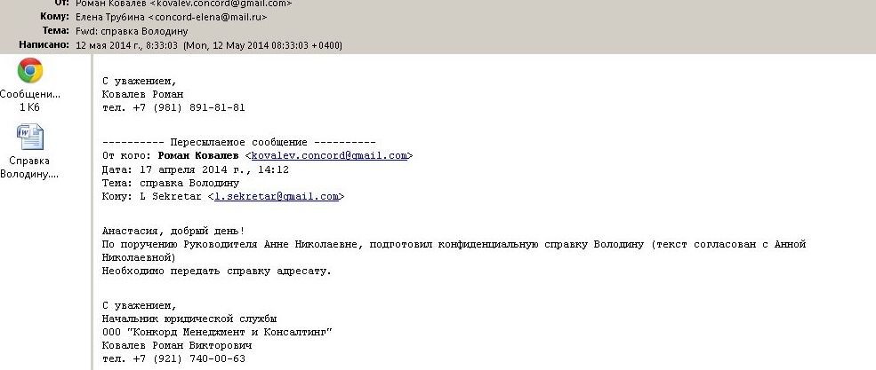
The email is supposed to address Roman Kovalev at Prigozhin's Concord Catering and Concord Management and Consulting LLC. Do you see the problem?
All the correspondence share the same traits. Either Ole'Yevgeniv (Prigozhin) is the cheapest Oligarch on the planet and uses gmail and yandex for company correspondence or it is a fake email. If the emails are faked, what the hell is the point of trying to convince you further? We already crossed the endzone and scored.
The image below shows what real authenticated Concord Catering and Concord Management and Consulting LLC contact information looks like. Can you see the difference right away? If you were spending $1 Million + on a project every month, wouldn't you give your project management something a little more secure than gmail and maybe just a touch snazzier?
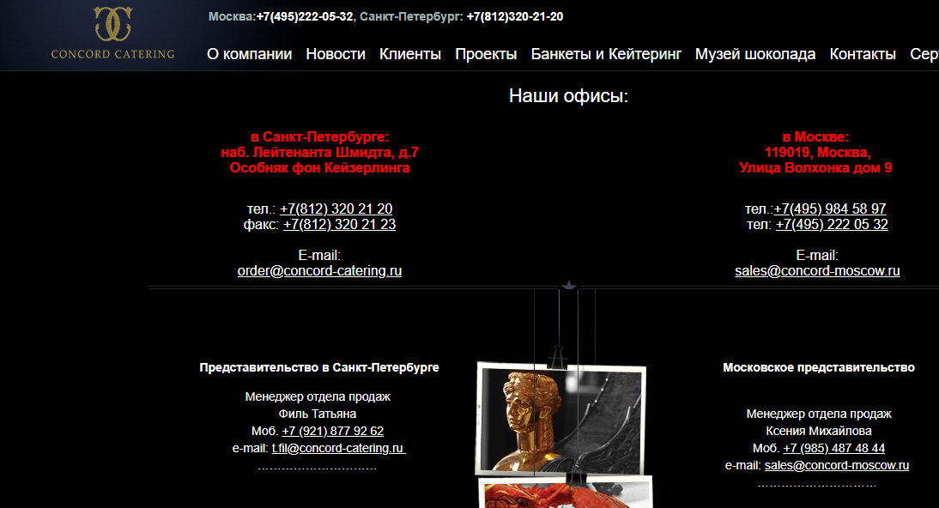
There are no gmail addresses here. If we look at another image we can get down to how elite these trolls were very quickly.
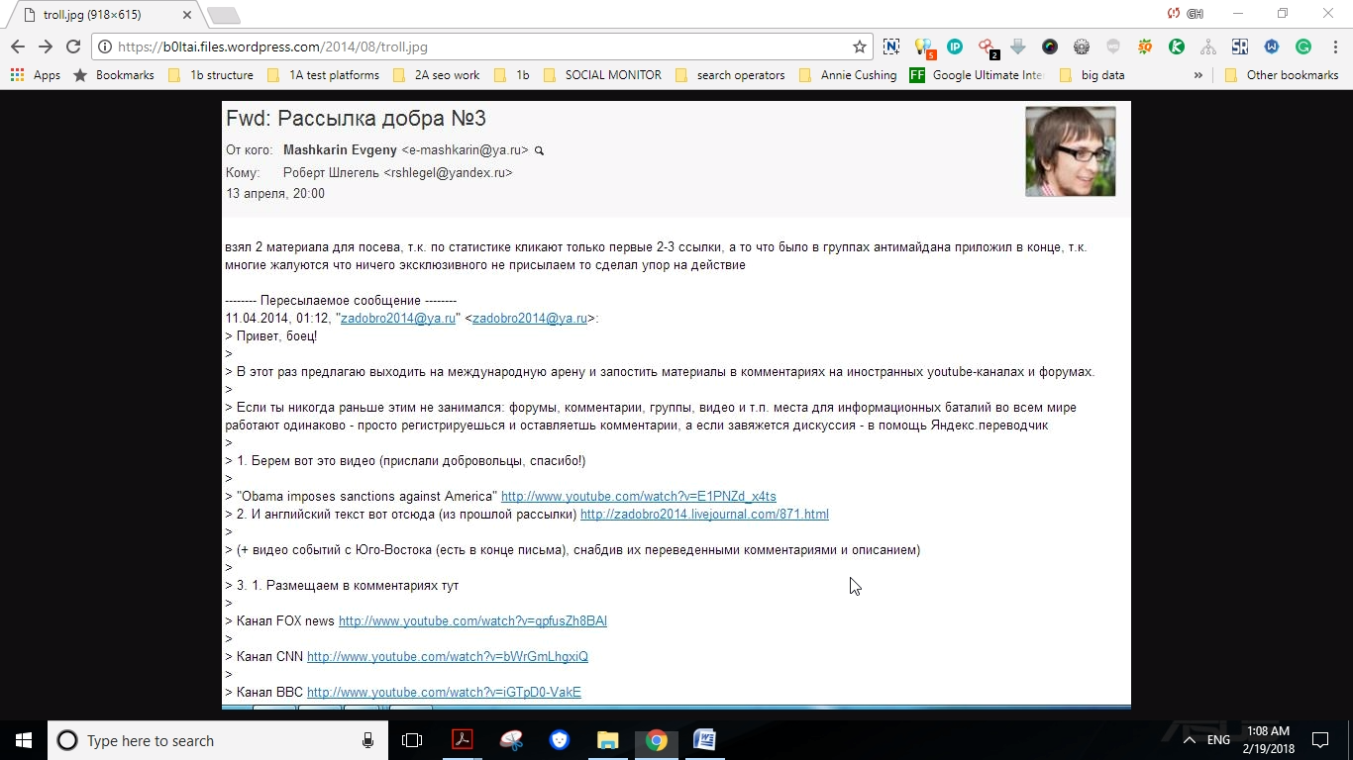
I clicked on the image at the hackers blog and if you look at the link on top, the name of the image appears-"troll.jpg" By itself it means nothing. But we've already found out what's going on. When you look at the communication, it is poorly formed instructions to post videos and comment.
How good is the supposed Information Operation unit of the Internet Research Agency in St. Petersburg?
According to Mueller's hackers, they were bad. No, beyond bad, they were barely literate in English, bad. They probably had a hard time getting directions to Starbucks, bad. Yes, I mean bad.

From the hackers in June, 2014- "Igor Osadchy is the head of the "external department" of the AII (Internet Research Agency, also known as the "trolley factory in Olgino"), that is, the very Prigozhin trolls working in bad English on foreign sites and flooding their "sincere" opinion forums and comments foreign media."
If this is the source Mueller is using, it's not just tainted information, it's information that is tainting you. Look at how this foreign information operation is playing out across American media and dividing society. The following shows these posts are from the hackers.
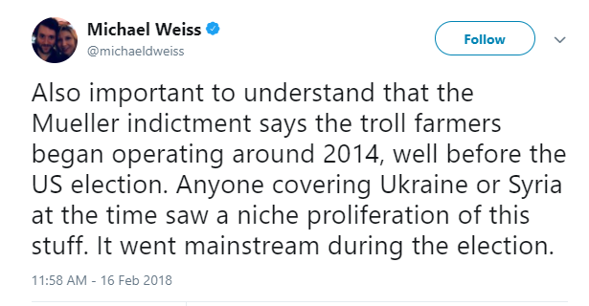
According to the Washington Post -The other staff mentioned are very incidental. I mean, it seems like they put down all the names they could get. Some were people that worked there in 2014-but most of these guys didn't work for the troll factory for a long time. They didn't even work for the troll factory during the elections.
Wikipedia- "The extent to which these Russians tried to influence public opinion using social media became widely known after a June 2014 BuzzFeed article greatly expanded on government documents published by hackers earlier that year."
Adrian Chen's non-article at the New York Times identifies the above as the source that Robert Mueller would eventually use. The hacking group using the Anonymous name, isn't even part of Anonymous.
At this point I can sit and list every article, publication, and journalist that have been taken in by this information operation, but what's the point.
Over the last 4 years I've researched and written many stories that are still breaking in media today I broke the story about Russian trolls and what would lead to Propornot in 2015.
If you want to support investigative research with a lot of depth, please support my Patreon page. You can also support my work through PayPal as we expand in new directions over the coming year. For the last 4 years it's been almost entirely self supportive effort which is something when you consider I live in Donbass.
I am adding a lot of detailed information to my patron page that doesn't make it into articles just because of the sheer volume of webpages it adds and sometimes continuity with the current subject matter can be problematic.
Next up- A damning expose showing who makes up Fancy Bear, who is behind them, and the real damage they are doing. Thank you for supporting my investigative journalism project. My goal is to provide real answers and real solutions.

